AWS, Hosting webpage on EC2.

04-08-2025

Tejas Kapade

1. Launch EC2 instance

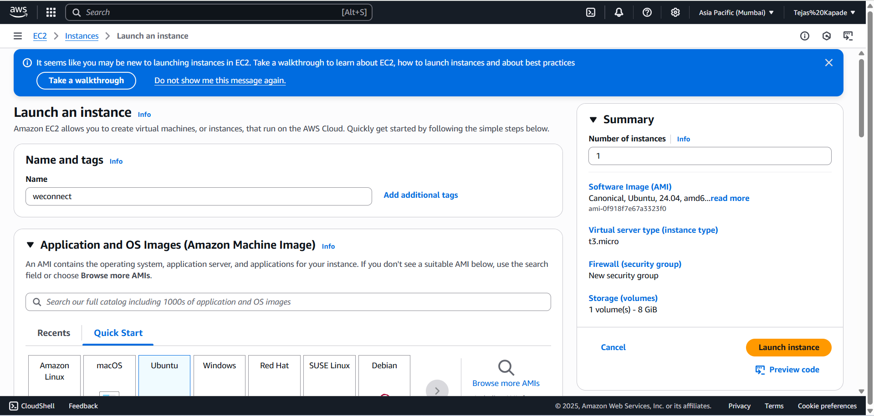

1. Connect with SSH

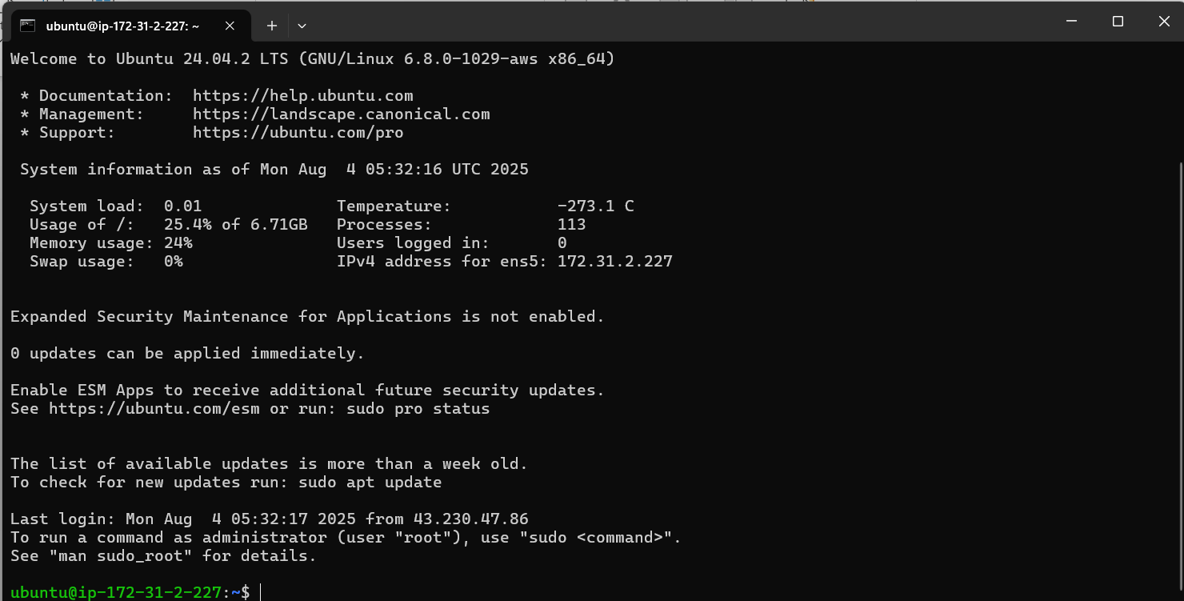

1. Update packages

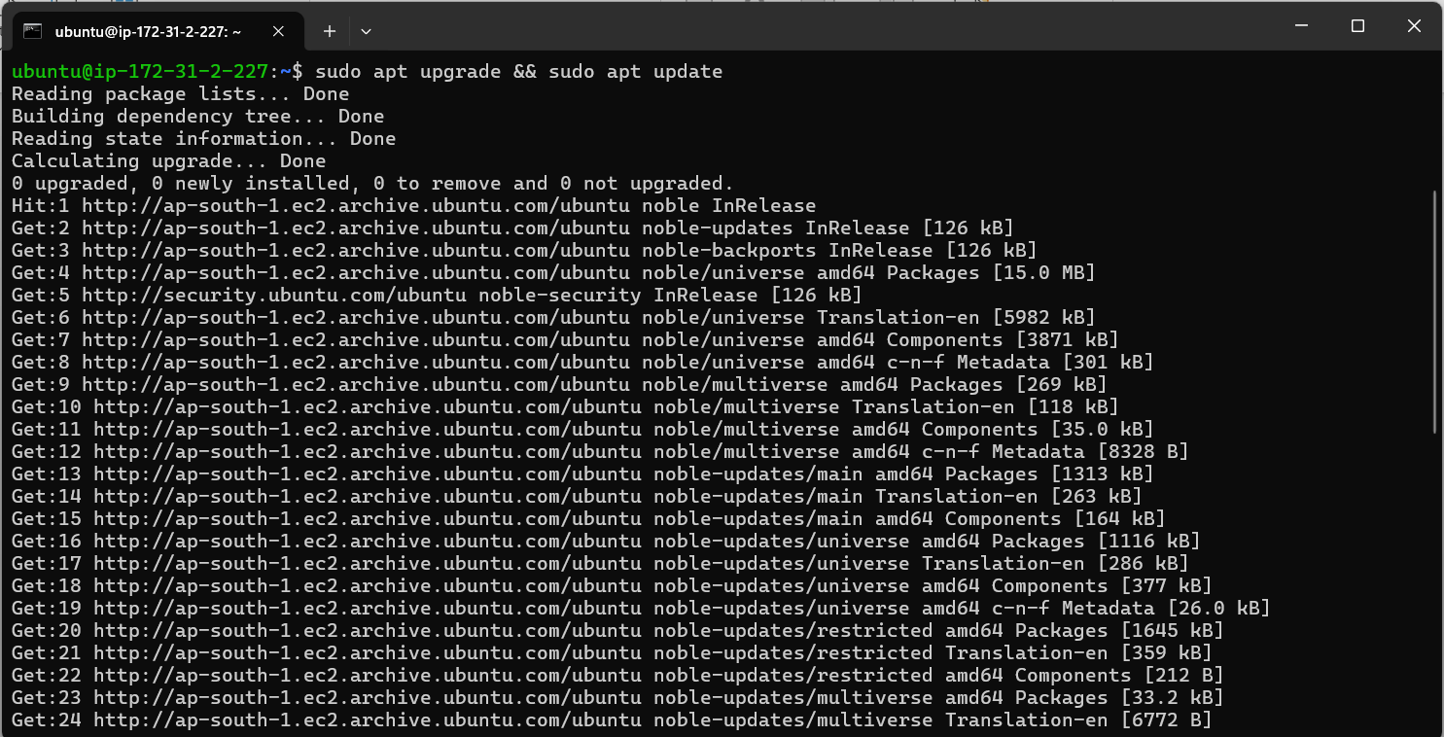

1. Install and start apache service

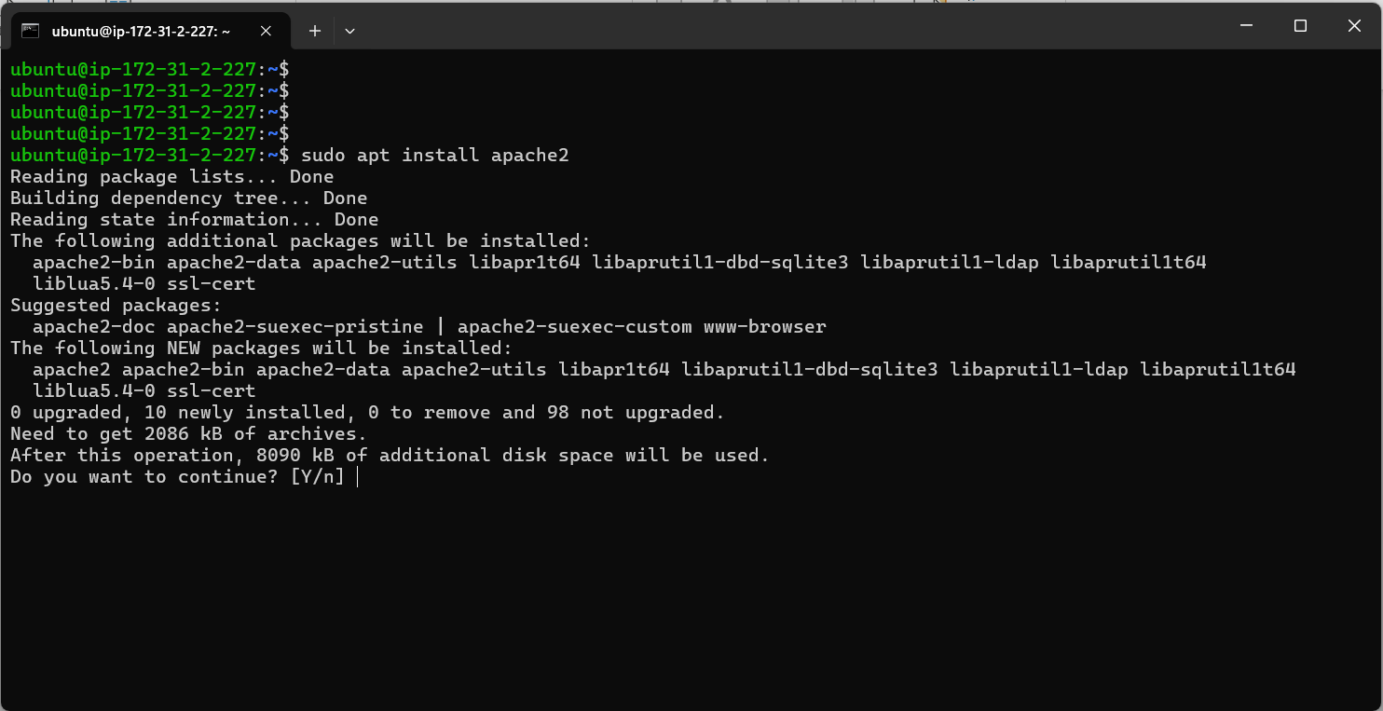

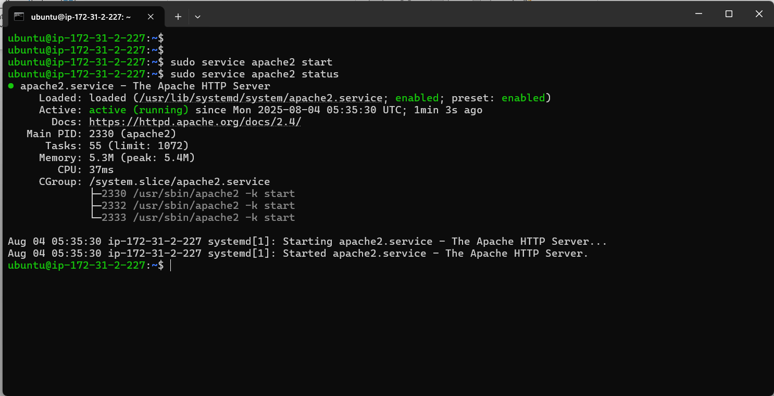

1. Create test HTML file for webpage

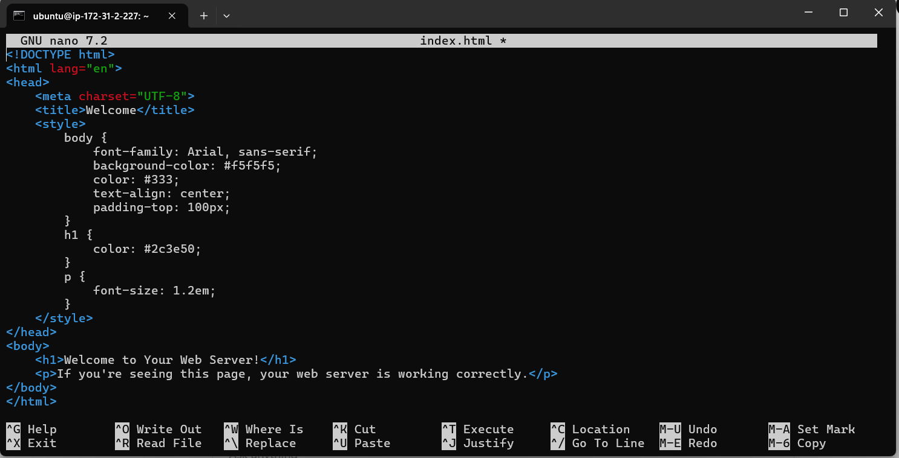

1. Put it on /var/www/html (default path for apache hosting)

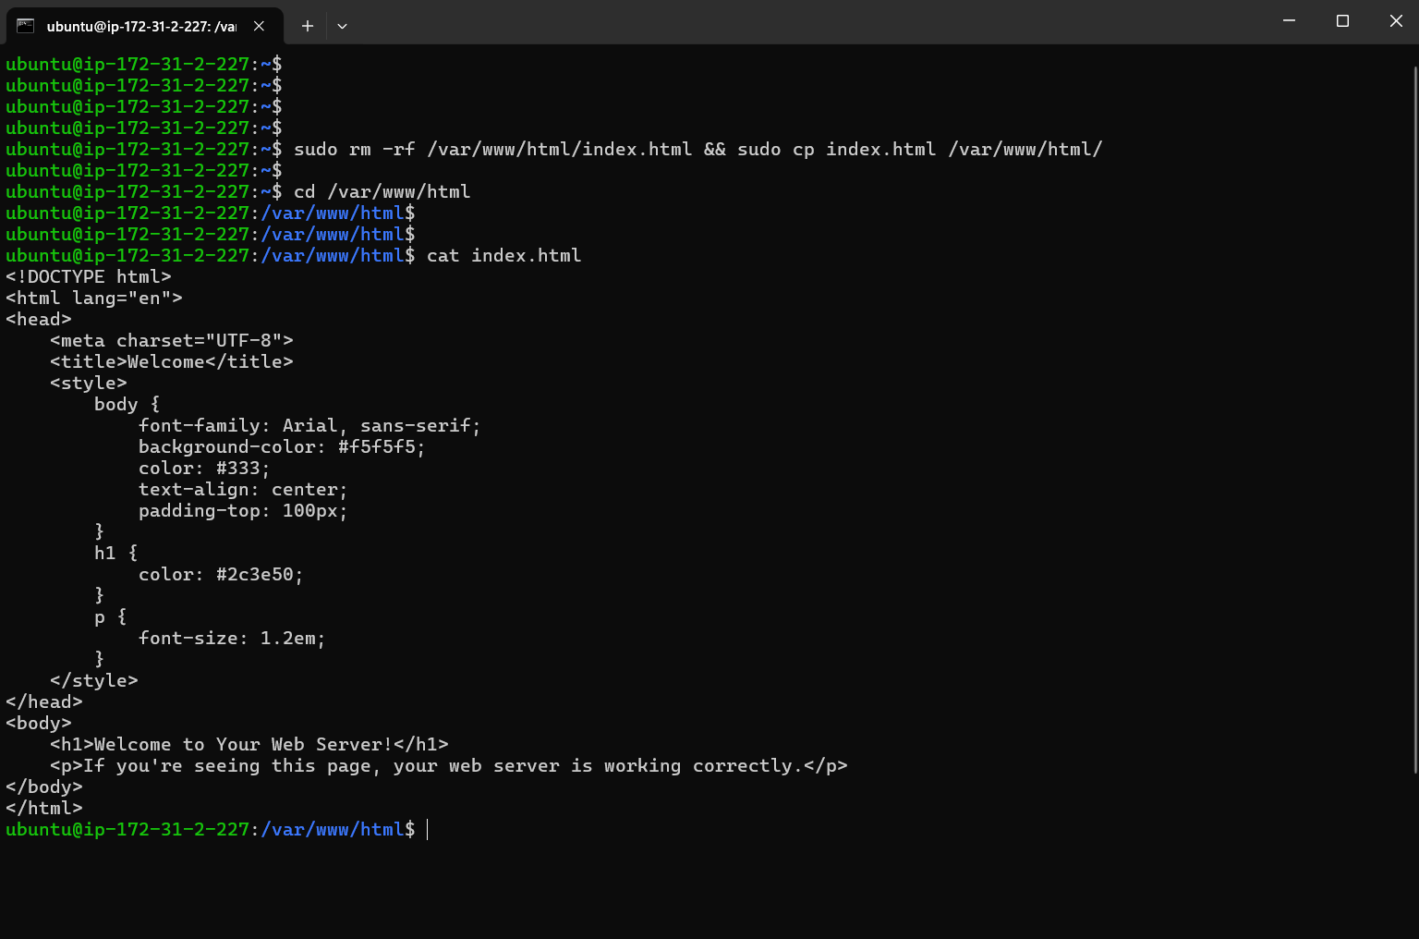

1. Check for webpage using public IP in URL

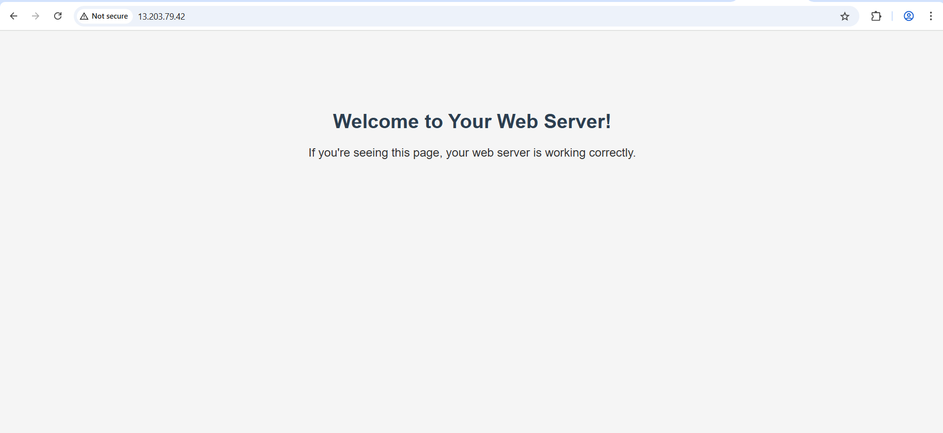

Apache server is now running.